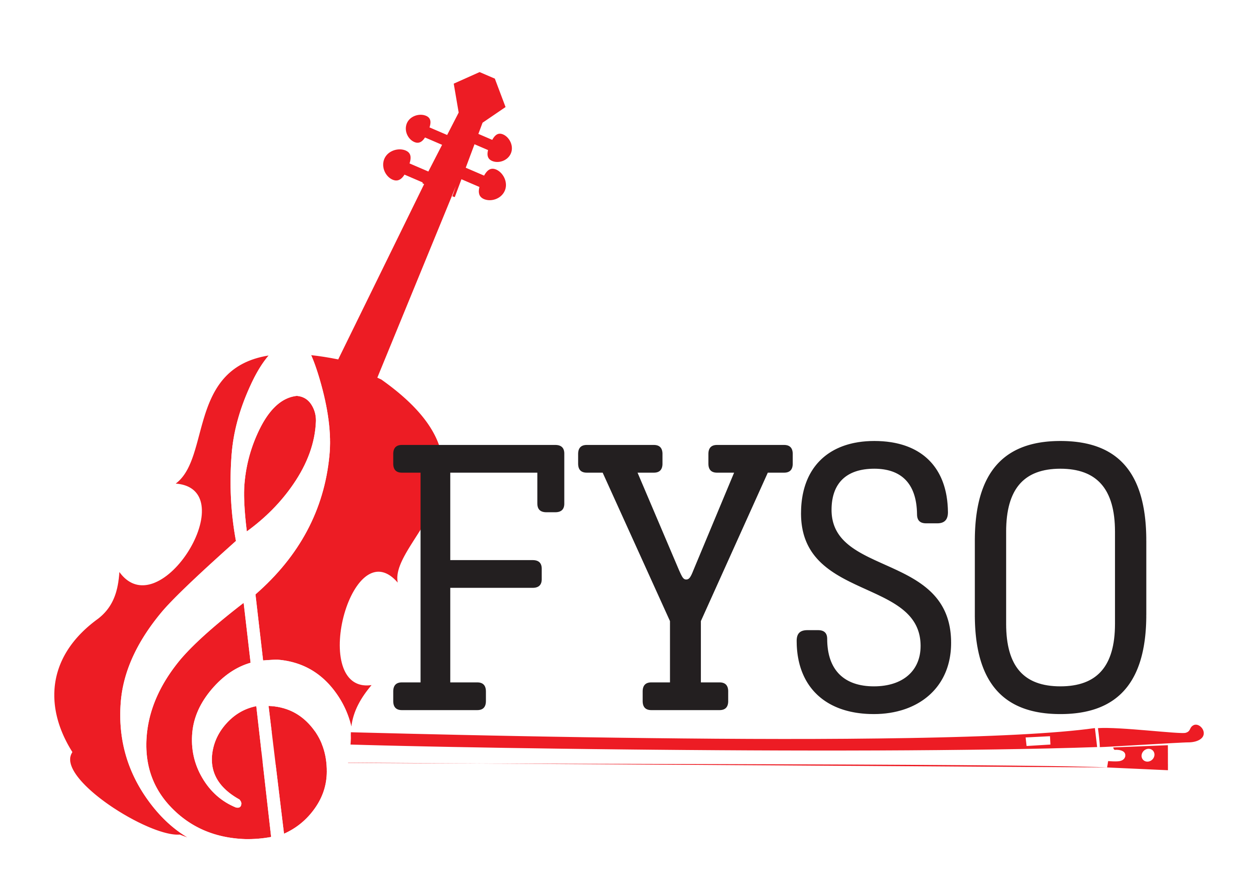Frisco Youth symphony Orchestra audition
We love to hear from you
Location: Accent Music Academy
April 21, 2019
2pm to 5pm
email:conductor@friscoso.org
Invite Strings/Woodwinds/Brass/Percussion players from 6th grade to 12 grade

